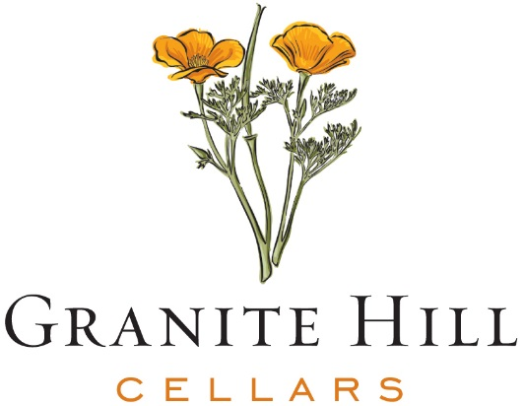

2019 Lodi Cabernet Sauvignon

About: Granite Hill Cellars is a newly released brand by the Kautz Family of Lodi, California. The name comes from the rocky and “granite” terroir the family’s vineyards grow on. The soft rolling hills, in conjunction with the Pacific Ocean Delta breezes make these vineyards ideal for grapes of distinction. Practicing “sustainability” for over 30 years, the family is committed to the longevity of their land and the environment around them.

Appellation: Lodi has been a famed region for growing Zinfandel grapes for many years, but it has been the last 10-15 years that they are shining through with other varieties, including Cabernet Sauvignon. The sub-AVAs for this wine come from Sloughhouse and Alta Mesa, which are located in the northern part of Lodi, just west of the Sierra Foothills.

About the Wine: The 2019 vintage displays aromas of dark cherries and toasted vanilla oak, followed up with flavors of black currants, blueberries, sweet raspberry and slight hint of tobacco and spice. The finish is lingering and flavorful with red currants and oak.

Pairing: Delicious with grilled meats, especially Tri-tip and ribeye or enjoy with wild game, such as venison, duck confit or a decadent dark chocolate dessert. Vegetarian Friendly & Gluten Free.

Technical Notes:

Blend: 80% Cabernet Sauvignon, 6% Petite Sirah, 5% Merlot
Alcohol: 14.5% Aging: 3 months, new French oak
RS: 1.83 g/l TA: 6.2 g/l
pH: 3.68 UPC: 7 24826 15251 3

www.granitehillcellars.com

