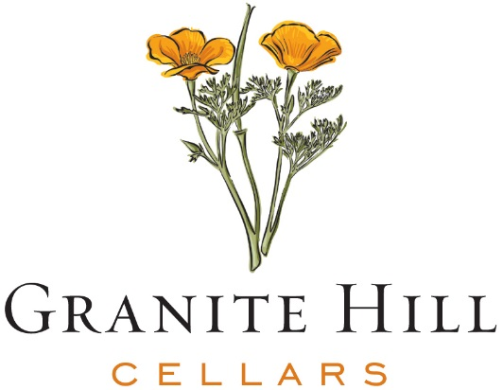

2018 Lodi Pinot Noir

About: Granite Hill Cellars is a newly released brand by the Kautz Family of Lodi, California. The name comes from the rocky and “granite” terroir the family’s vineyards grow on. The soft rolling hills, in conjunction with the Pacific Ocean Delta breezes make these vineyards ideal for grapes of distinction. Practicing “sustainability” for over 30 years, the family is committed to the longevity of their land and the environment around them.

Appellation: Lodi has been a famed region for growing Zinfandel grapes for many years, but it has been the last 10-15 years that they are shining through with other varieties, including Pinot Noir. The sub-AVAs for this wine come from Jayhant and Mokelumne River, which are located in the western part of Lodi.

About the Wine: The 2018 vintage is rich with flavors of black cherries, cranberries, cloves, tobacco with a touch of caramel and vanilla. The fruit forward style finishes lush and full.

Pairing: Delicious with duck confit, barbecued chicken, pork tenderloin, mushroom risotto and grilled vegetables.

Technical Notes:

Blend: 84% Pinot Noir, 8% Petite Sirah,
4% Merlot, 4% Petite Verdot

Alcohol: 13.5% Aging: 4 months, new French oak
RS: 1.2 g/l TA: 5.30 g/l
pH: 3.57 UPC: 7 24826 52251 4

Granite Hill Cellars, 6111 E. Armstrong Road, Lodi, CA 95240, USA Tel. +1 209 369 1911

